**Project Proposal**

**Team & Names:** SRCAG Bears

Mehri Sadri

Tomas Moshi

**Idea title:** The Fentanyl Fight

**Idea**

**Who (Stakeholder):** Hospitals and non profits. These are the places that distribute the Narcan to the community.

**Problem:**

* There is a certain supply of Narcan in San Diego County, with a certain demand as well
* There is a current growing problem of fentanyl usage and overdoses, which are almost always fatal, due to our proximity to the border
* There is a lack of awareness surrounding the overall effectiveness of Narcan (75% to 100% effective when used correctly,) which could save numerous lives

**So what:**

* Reduce the # of deaths in San Diego County among youth, unhoused individuals, and other demographics
* Help hospitals, nonprofits, and other agencies optimize limited resources

**In our Presentation:**

* Regression model that can predict the most optimal distribution of Narcan by Zip Code/general location
* Regression model that can predict the rise in fentanyl use and death over 5-10 years
* Model displayed in map form, where the stakeholder can interact with the map to view exact Qs of Narcan per zip code in San Diego County

Regression model:

* that can predict the rise in fentanyl use and death over 5-10 years.
* When people use Narcan, it can show the decrease in deaths and Fentanoyl use

**News Articles:**

* How Fentanoyl can lead to mental health issues that can lead the rise to homelessness, deaths,and
* How Narcan can decrease deaths

**Visual:**

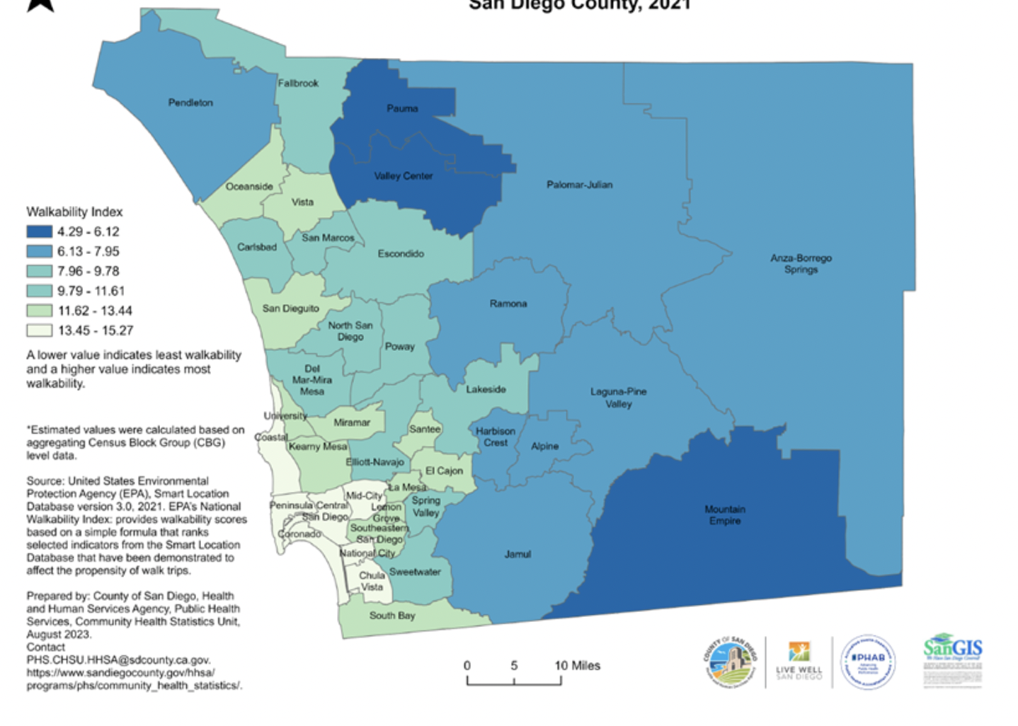

**Data Collection Notes**

**LIVE WELL SAN DIEGO (Q1+Q2 2024):** chrome-extension://efaidnbmnnnibpcajpcglclefindmkaj/https://www.sandiegocounty.gov/content/dam/sdc/hhsa/programs/phs/od2a/Q1_2024_Overdose%20Quarterly%20Report.pdf